* Design TM using simulator to accept the input string Palindrome ababa

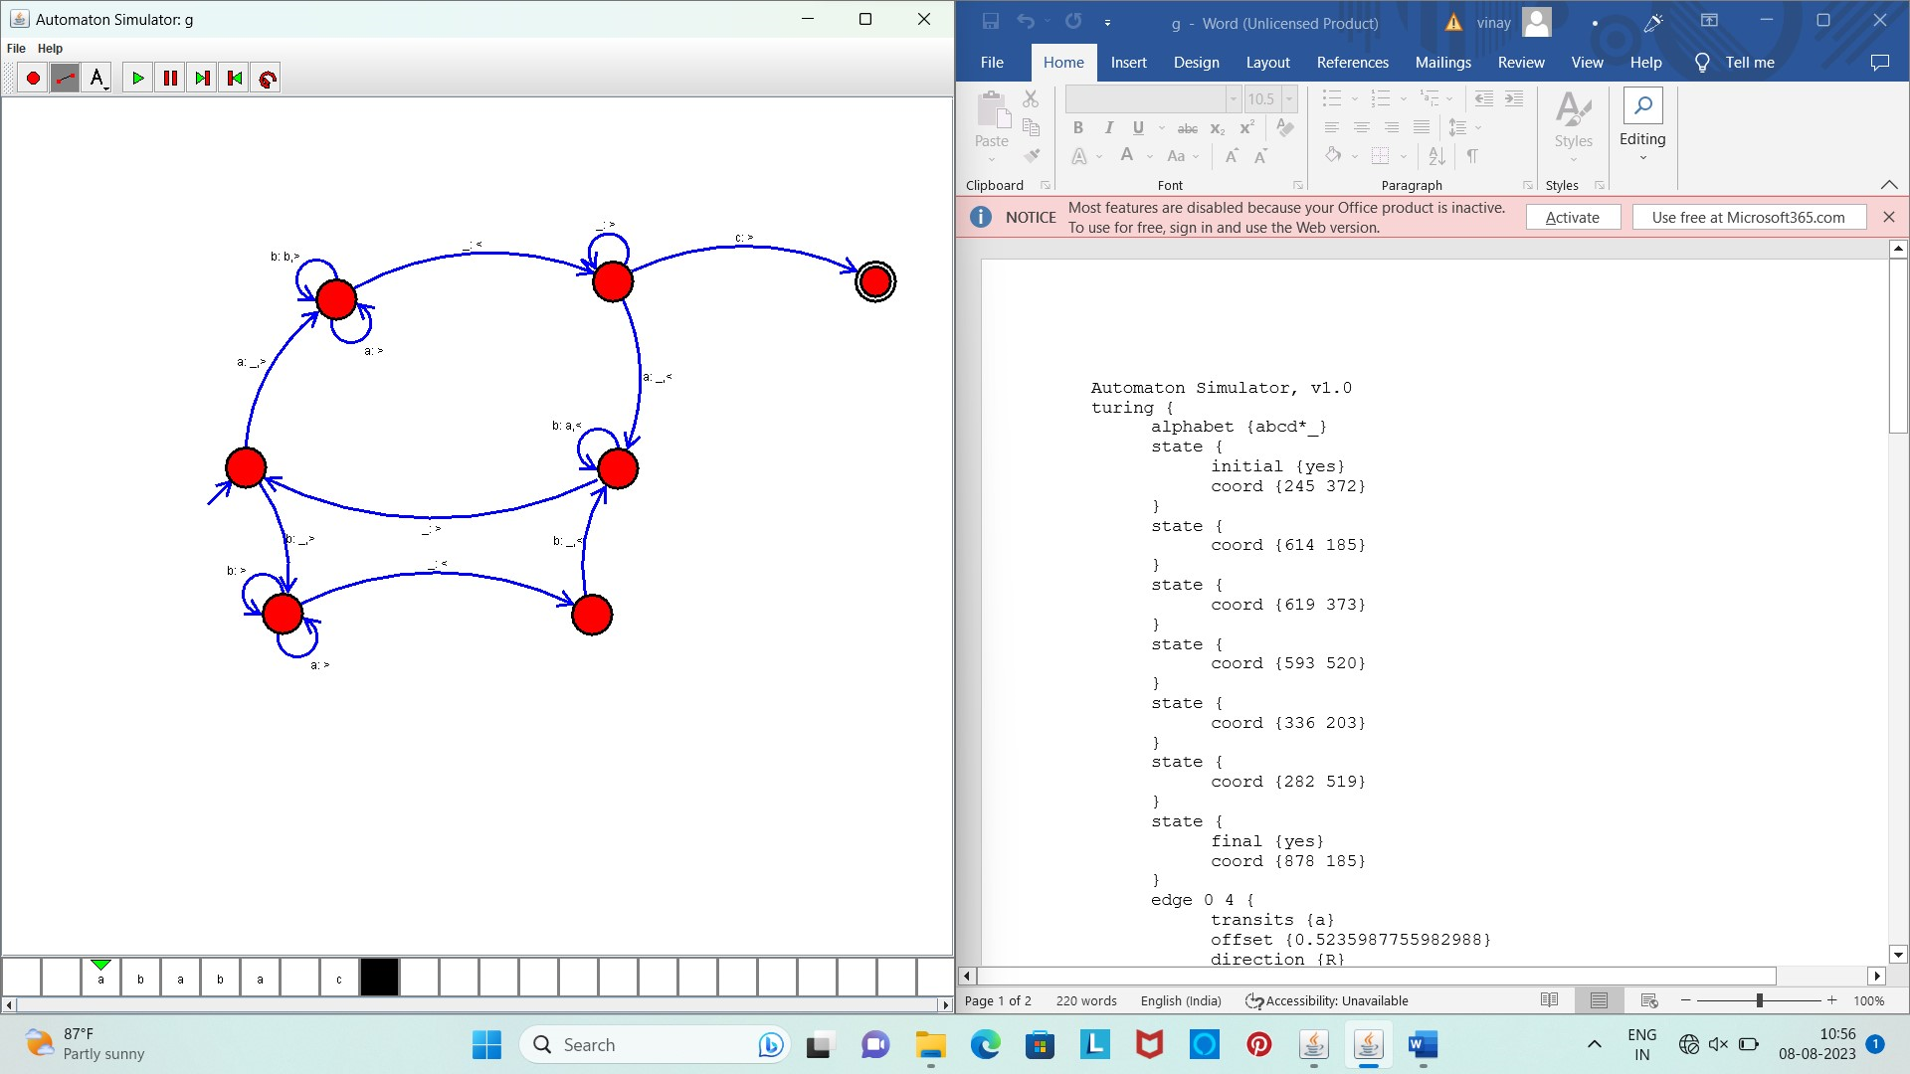

Result :

* The simulator is accepted the input string Palindrome ababa by using the above TM diagram